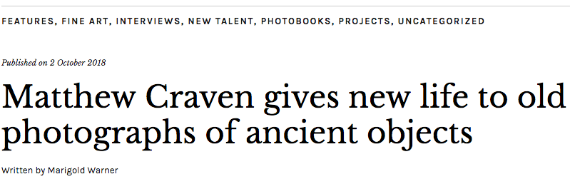
Matthew Craven's new book, PRIMER, uses images of found in old school textbooks and reshapes them into mind-bending collages

“I’m always picking things up and taking them home with me,” says Matthew Craven. “Just general knick knacks.” His finds include succulents, unusual rocks, and little bits of pottery that he displays in his home inTopanga Canyon, Los Angeles. But out of all of the things he collects, which also includes records and vintage NBA t-shirts, perhaps his strangest and largest collection is of school textbooks.

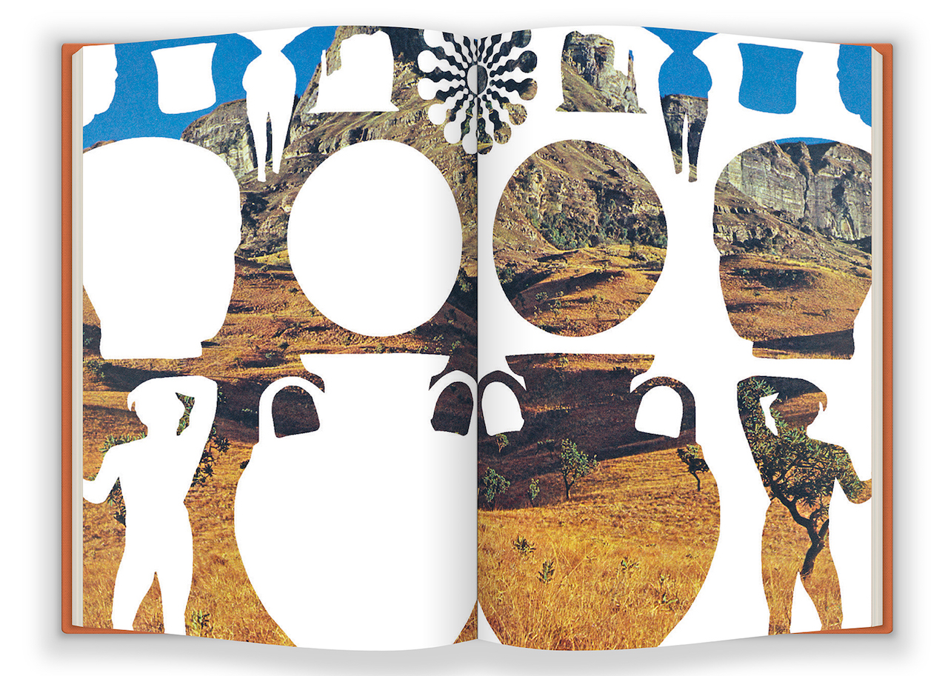

The books usually date back to the 1950s or 60s, but “the older the better” says Craven. After finding a copy he likes in a second-hand book store, he’ll trawl through the internet, contacting sellers that may have many more in storage – usually schools or libraries. “Personally, it satisfies me to be able to find these old materials and preserve them in some little way possible,” he says.

He then uses these books as source material for intricate collages, in which every element – from the images themselves to the paper they’re stuck on – are made out of found materials. Part of what satisfies him about this work is the thought of giving new life to the images, shot and reproduced so many years ago for “outdated learning tools that don’t have a home in this world anymore”.

For his new book, PRIMER, Craven wanted to reference the older publications, but also let the images stay smudgy, to “like a human had made it”. So he mimicked the fonts from books on ancient history and used an off-white, matte paper, “so dry it pulls the moisture out of your fingers”.

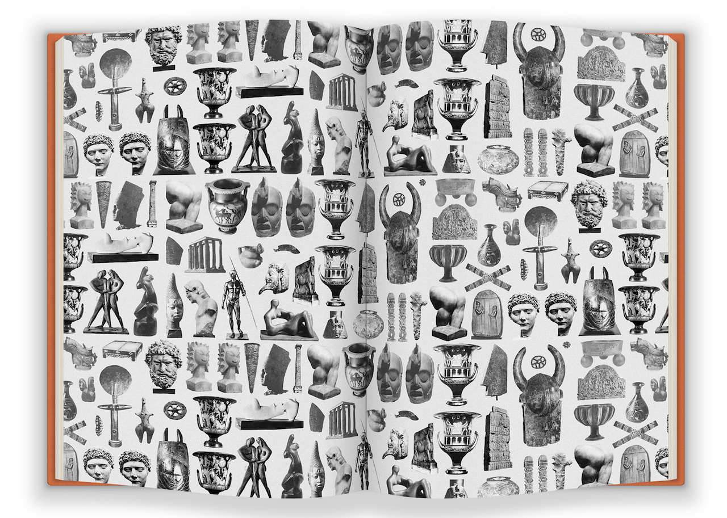

Craven now feels a kinship towards handmade objects, but he didn’t always work with paper. When he started his MFA at the School of Visual Arts in New York, he thought he would become a painter, but didn’t always feel sure about his direction. Then one day, out of boredom, he started drawing on some photographs he’d been given of the American West; putting them together, and hanging them up in the studio, he found people were struck by them.

Working with found materials also appeals to him from an environmental point of view, because when he was studying, he realised that, despite wanting to be progressive, artists “make some of the worst messes”. “We’re using toxic chemicals, and we leave this huge trail of waste behind,” he says.

An added bonus of this recycling is that it’s also less expensive to make than other art forms. “Work on paper is such a simple idea, it doesn’t take a lot of money or resources to work that way and I’ve always been drawn to that,” he says. “Any little bit that I can help preserve is a nice feeling.”

www.matthewcraven.com PRIMER by Matthew Craven is published by Anthology Editions and is available to purchase for $45 from www.anthologyeditions.com

